Elastic Load Balancer

• An Elastic Load Balancer is a service that uniformly distributes network traffic and workloads across multiple servers

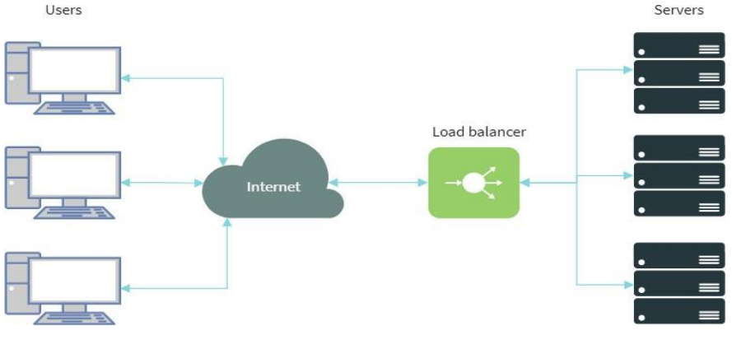

Types of Load Balancer

• Classic Load Balancer

• Application Load Balancer

• Network Load Balancer

• Gateway Load Balancer

**Classic Load Balancer (Equally divided traffic all machine)**

A Classic load balancer distributes equally incoming application traffic across multiple EC2 instances in multiple Availability Zones.

This increases the fault tolerance of your applications.

Elastic Load Balancing detects unhealthy instances and routes traffic only to healthy instances.

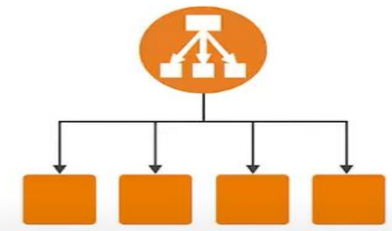

• Create Linux EC2 Machine

• Bootstrap Script Code:

#!/bin/bash

sudo su

yum update -y

yum install httpd -y

cd /var/www/html

echo "LoadBalancer-1" > index.html

service httpd start

chkconfig httpd on

• Enable HTTP Port

• Create Second Linux EC2 Machine

• Bootstrap Script Code:

#!/bin/bash

sudo su

yum update -y

yum install httpd -y

cd /var/www/html

echo "LoadBalancer-2" > index.html

service httpd start

chkconfig httpd on

• Enable HTTP Port

**• Create Load balancer**



• Click on Create for Classic Load Balancer

• Define Load Balancer

• Assign Security Group

• Configure Security Settings

• Configure Health Check (Important)

• Enter Response timeout as 2

• Enter Interval as 5

• Enter Unhealthy threshold as 2

• Enter healthy threshold as 2 Classic Load Balancer

• Add EC2 Instances

• Add Tags

• Review

• Click on Create

• Copy DNS Name & Paste in the browser

• Stop First EC2 Machine

**Response Timeout**: The amount of time to wait when receiving a response from the health check, in seconds. Valid values: 2 to 60

**Interval**: The amount of time between health checks of an individual instance, in seconds. Valid values: 5 to 300

**Unhealthy Threshold:** The number of consecutive failed health checks that must occur before declaring an EC2 instance unhealthy. Valid values: 2 to 10

**Healthy Threshold**: The number of consecutive successful health checks that must occur before declaring an EC2 instance healthy. Valid values: 2 to 1.

**Application Load Balancer**

Application Load Balancer routing traffic to targets based on the content of the request.

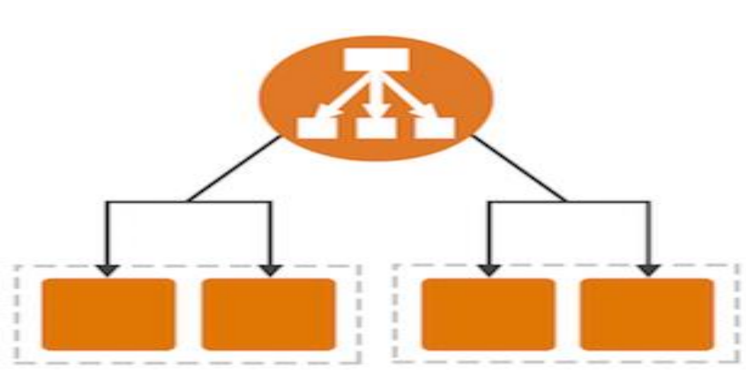

• Create Linux EC2 Machine

• Enable HTTP Port

• Install Web server

• Create html file in wwwroot folder

• Create one more folder & create the html file Application Load Balancer

• Create Second Linux EC2 Machine

• Enable HTTP Port

• Install Web server

• Create html file in wwwroot folder

• Create one more folder & create the html file

• Create Target Group



• Click on Create Target Group

• Enter the Name of the Target Group Name

• Click on Advanced health Check Settings

• Click on Next

• Select the machine & Click on Include as pending below

• Click on Create target group

• Create one more target group for second machine

• Create Application Load Balancer



• Click on Create Load Balancer

• Click on Create for application Load balancer

• Enter the Name

• Select all Availability zone

• Select our security group

• Select Default Target Group (First Target Group)

• Click on Create Load Balancer

• Now check our target group

• Go to our Application load Balancer

• Go to Listeners tab

• Select the listener

• Click on edit

• Select the second target group

• Click on save changes

• Click on View/edit rules

• Click on Add Rules

• Click on Insert rule

• Select the condition as Path

• Enter the path & forward to first machine

• Add another Rule

• For the second machine rule it’s mandatory to mention * after the path

• Save the Load Balancer

• Copy the DNS and Paste in Browser

• Change the path as per the folders we have created in the webservers

• **Listener**: A listener is a process that checks for connection requests.

• **Response Timeout**: The amount of time to wait when receiving a response from the health check, in seconds. Valid values: 2 to 60

**• Interval**: The amount of time between health checks of an individual instance, in seconds. Valid values: 5 to 300

• **Unhealthy Threshold**: The number of consecutive failed health checks that must occur before declaring an EC2 instance unhealthy. Valid values: 2 to 10

• **Healthy Threshold**: The number of consecutive successful health checks that must occur before declaring an EC2 instance healthy. Valid values: 2 to 10

**Network Load Balancer**

Network Load Balancer routing traffic to targets based on the port number. It can respond to millions of requests every second

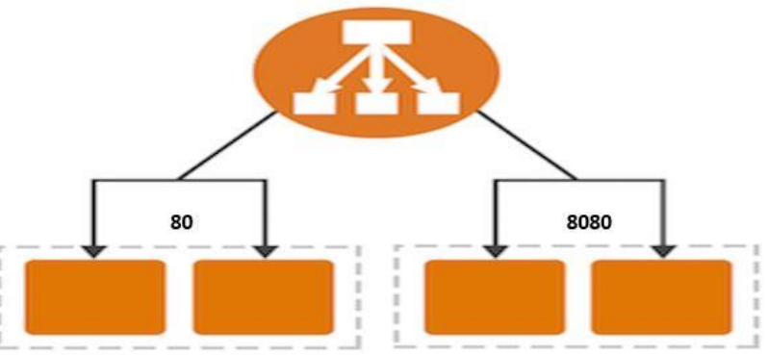

• Create First Linux EC2 Machine

• Bootstrap Script Code:

• Enable the Type as HTTP

• Create Second Linux EC2 Machine

• Bootstrap Script Code:

• Enable the Type as HTTP

• Enable Custom TCP Type & Change the Port Range to 8080

• Now Check the Public IP Address for both the Machines

• Add : 8080 Port number for Second EC2 Machine

• Connect Second EC2 Machine using Putty

• Change the User

sudo su

• Change folder

cd /etc/httpd/conf

• Edit httpd.conf file

vi httpd.conf

• Convert file into insert mode by pressing i

• Change Listen to 8080

• Save the file Press ESC :wq!

• Restart the server

service httpd restart

• Create Target Group



• Click on Create target group

• Enter the name of Target Group Name

• Change Protocol to TCP & Port number needs to be 80 for the first Machine

• Click on Next

• Add first Machine as Target

• Click on Create target group

• Create Target group for Second Machine Enter port number as 8080

• Create Network Load balancer



• Click on Create For Network Load balancer

• Enter the name of Load balancer

• Map all the subnet

• Select Listener & Target group

• Click on Create load balancer

• Now check our load balancer

• Go to Listeners tab

• Click on Add Listener

• Change port number to 8080

• Add Action to Forward to

• Select Second Machine

• Click on Add Listener

• Now Copy the DNS Name